Day: 15 (02-11-2026) | AWS VPC Setup & Management | Documented By:
Task – 3 | AWS VPC Setup & Management | Sujit T K

- Create VPC with name aji-vpc CIDR: 10.1.0.0/16
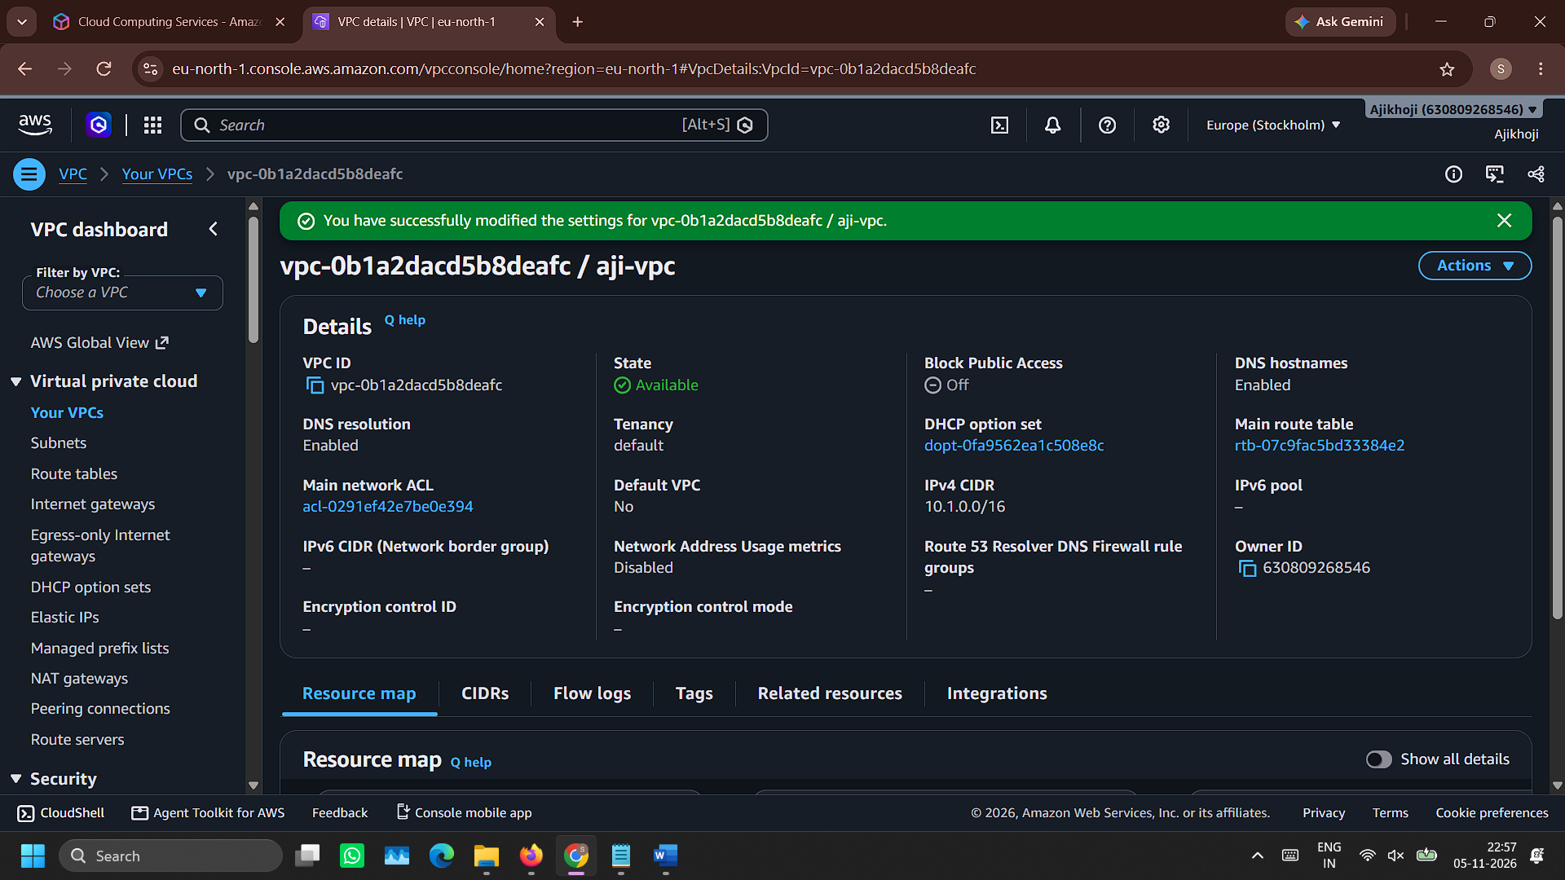
- Create public subnet with name aji-public-subnet
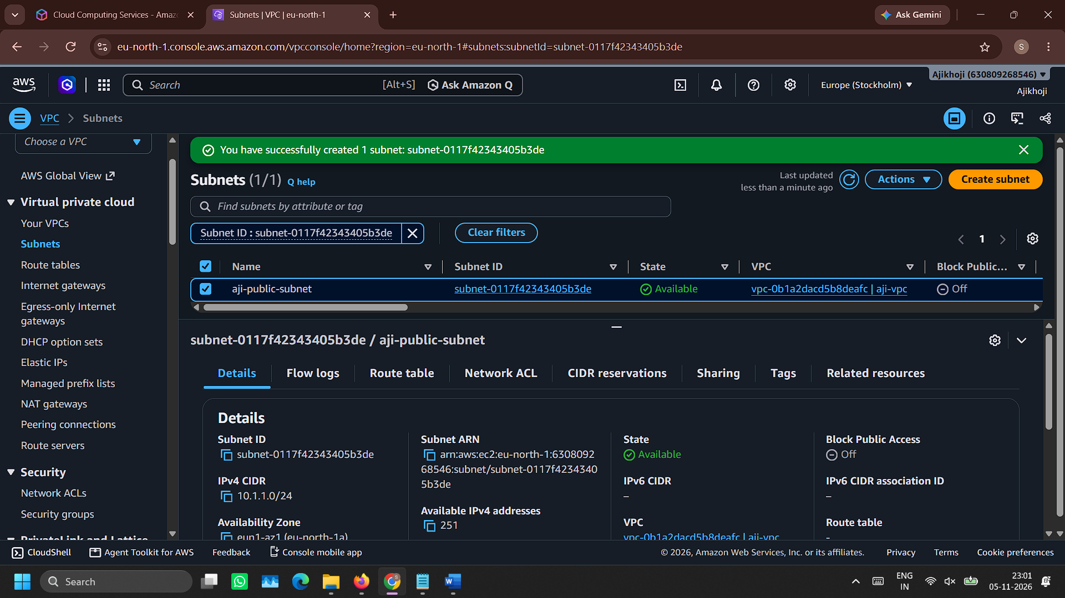

- Create private subnet with name aji-private-subnet
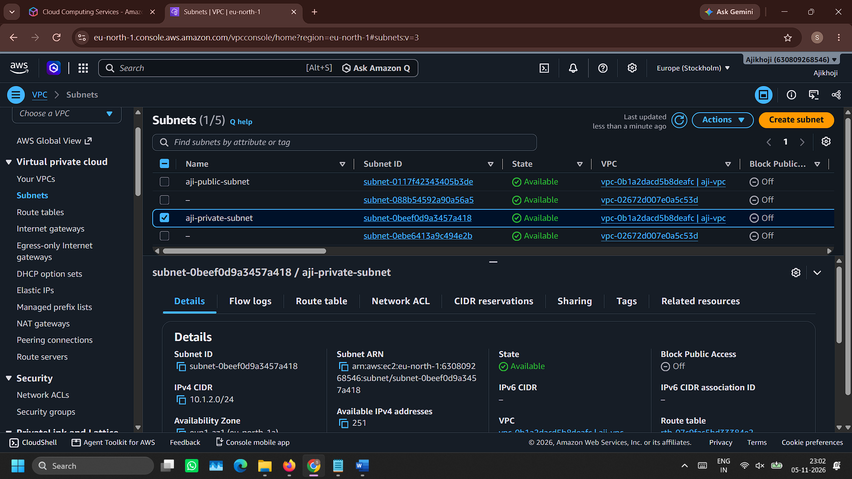
- Create an Internet Gateway named aji-internet-gateway
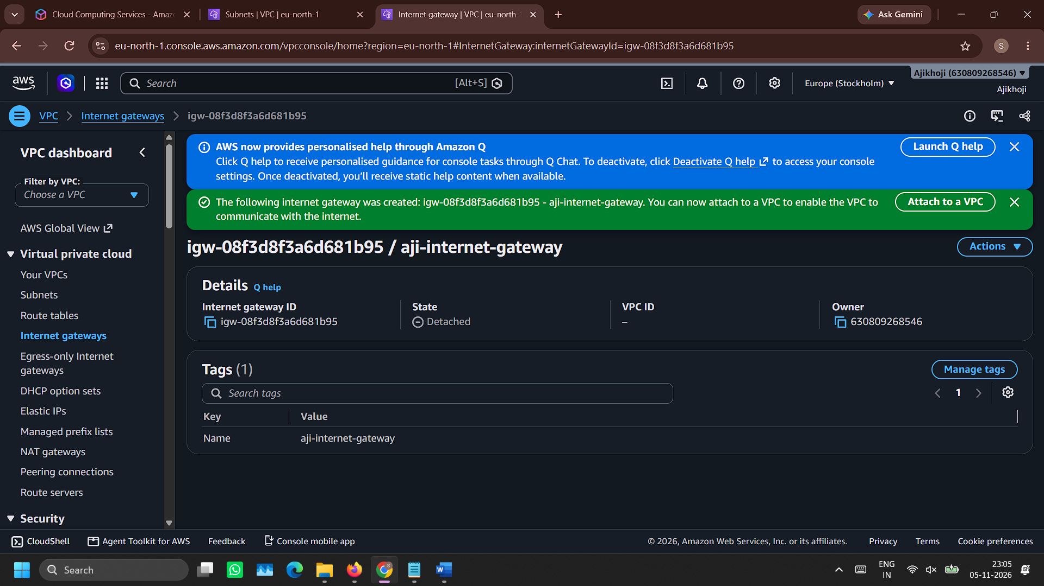

- Attach to VPC aji-vpc
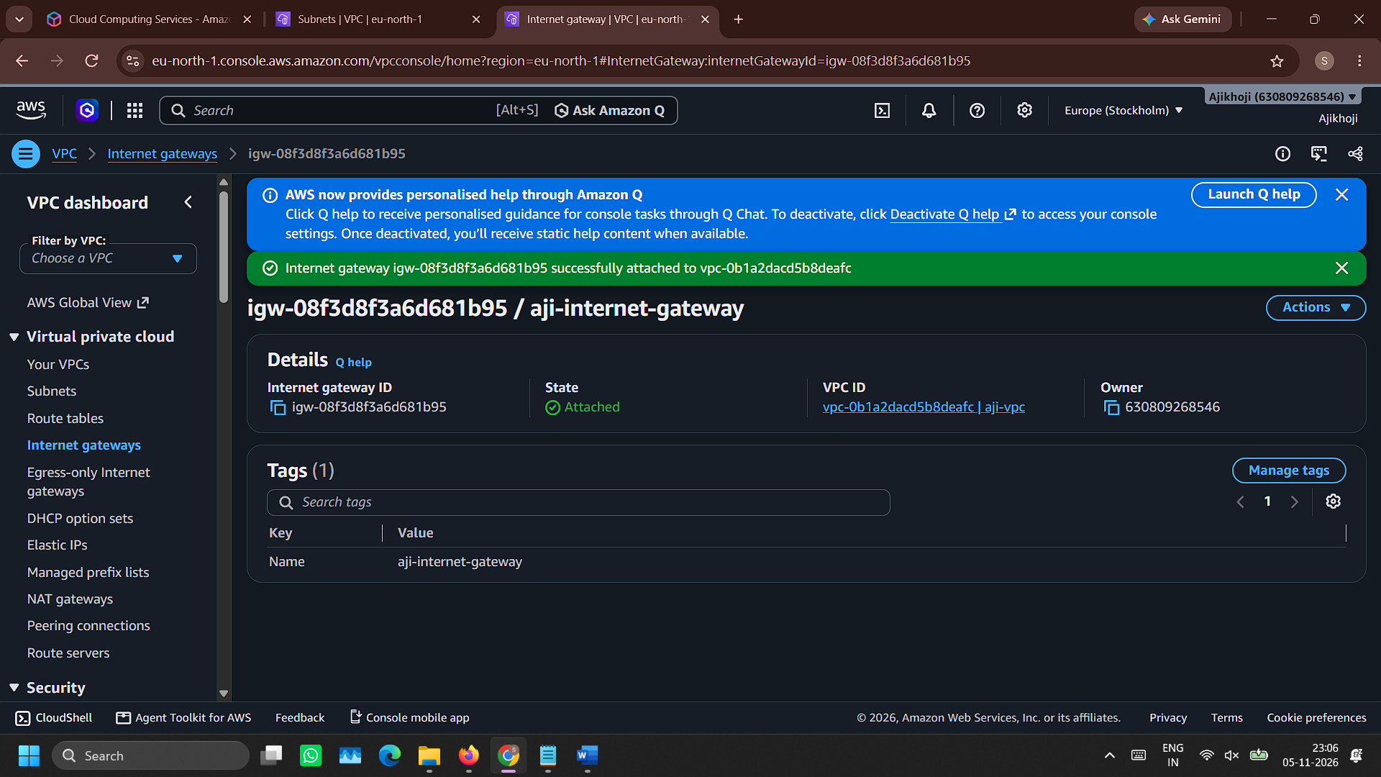
- Create a route table for public subnet with name aji-public-route-table
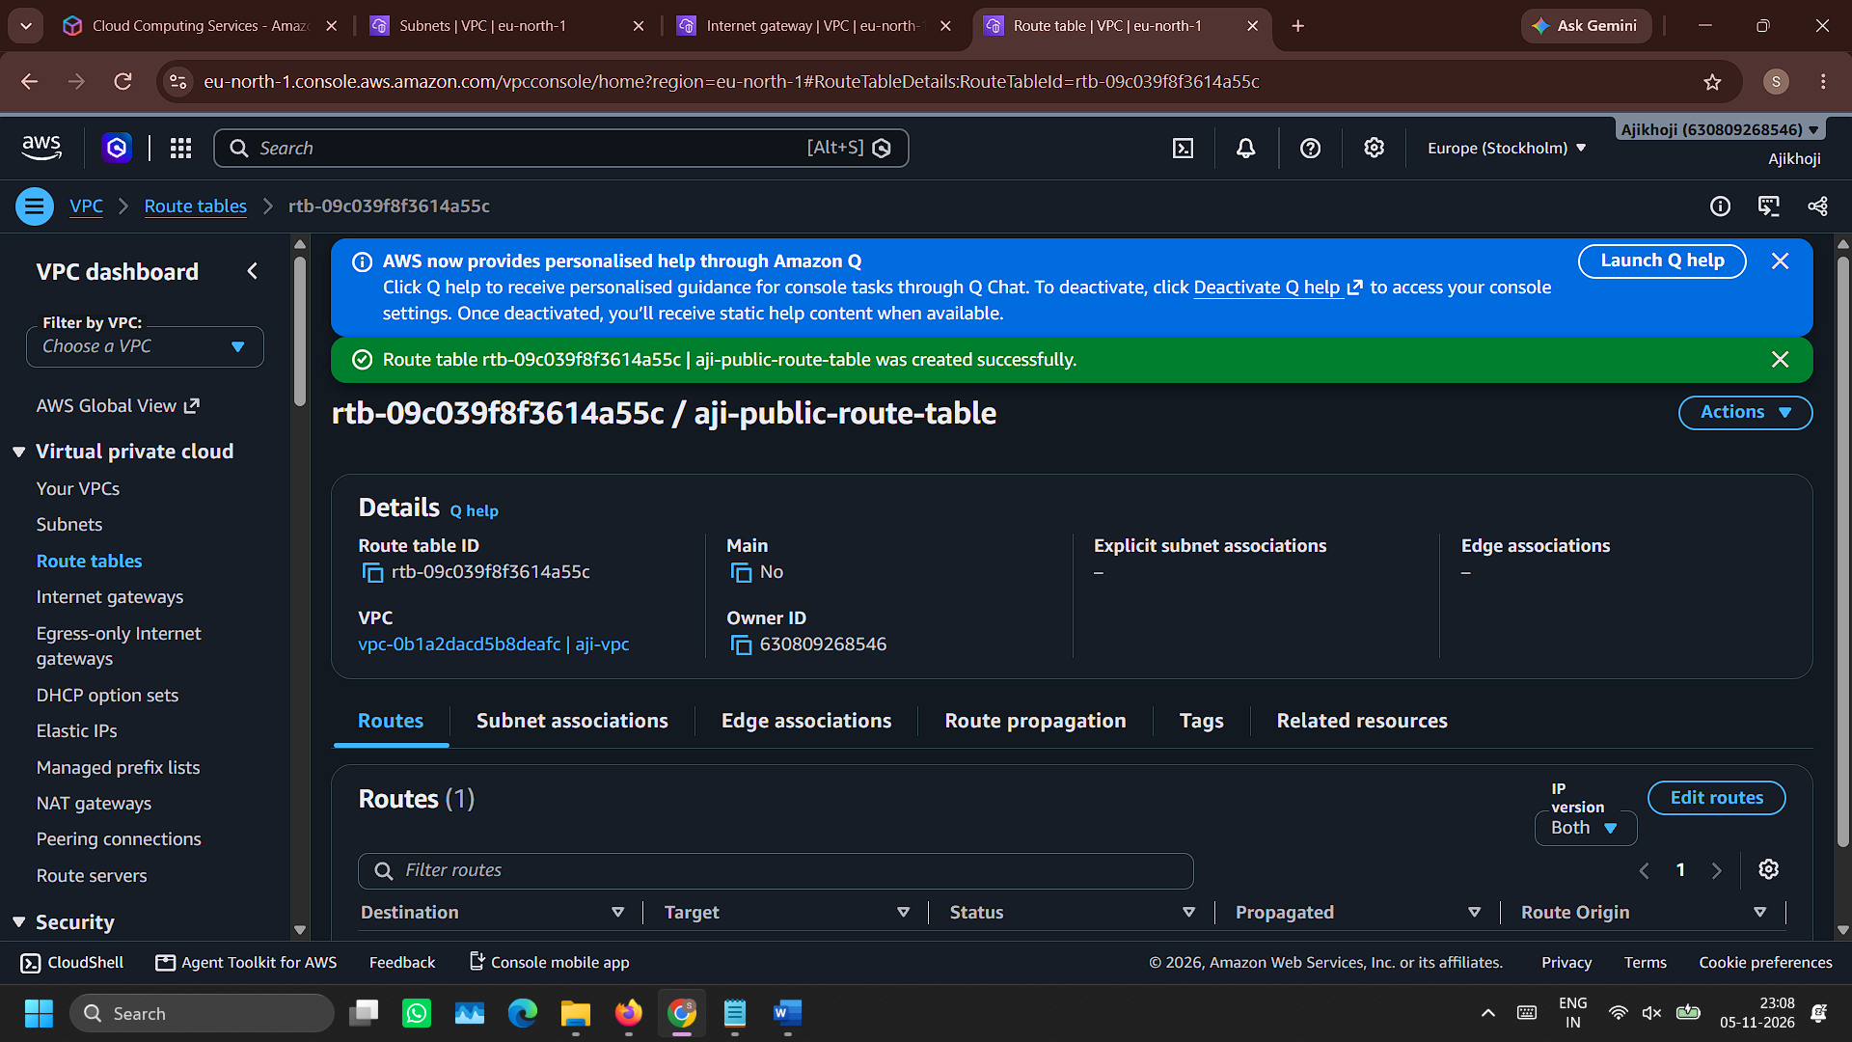

- Attach Internet gateway aji-internet-gateway to route aji-public-route-table
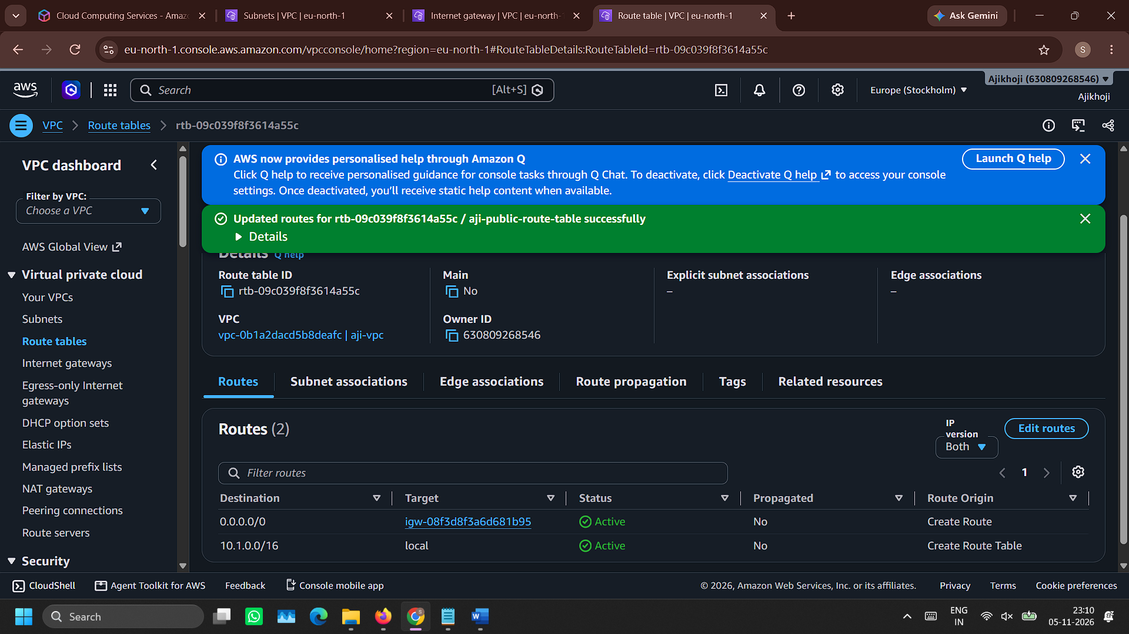

- Associate subnet aji-public-subnet with route table aji-public-route-table
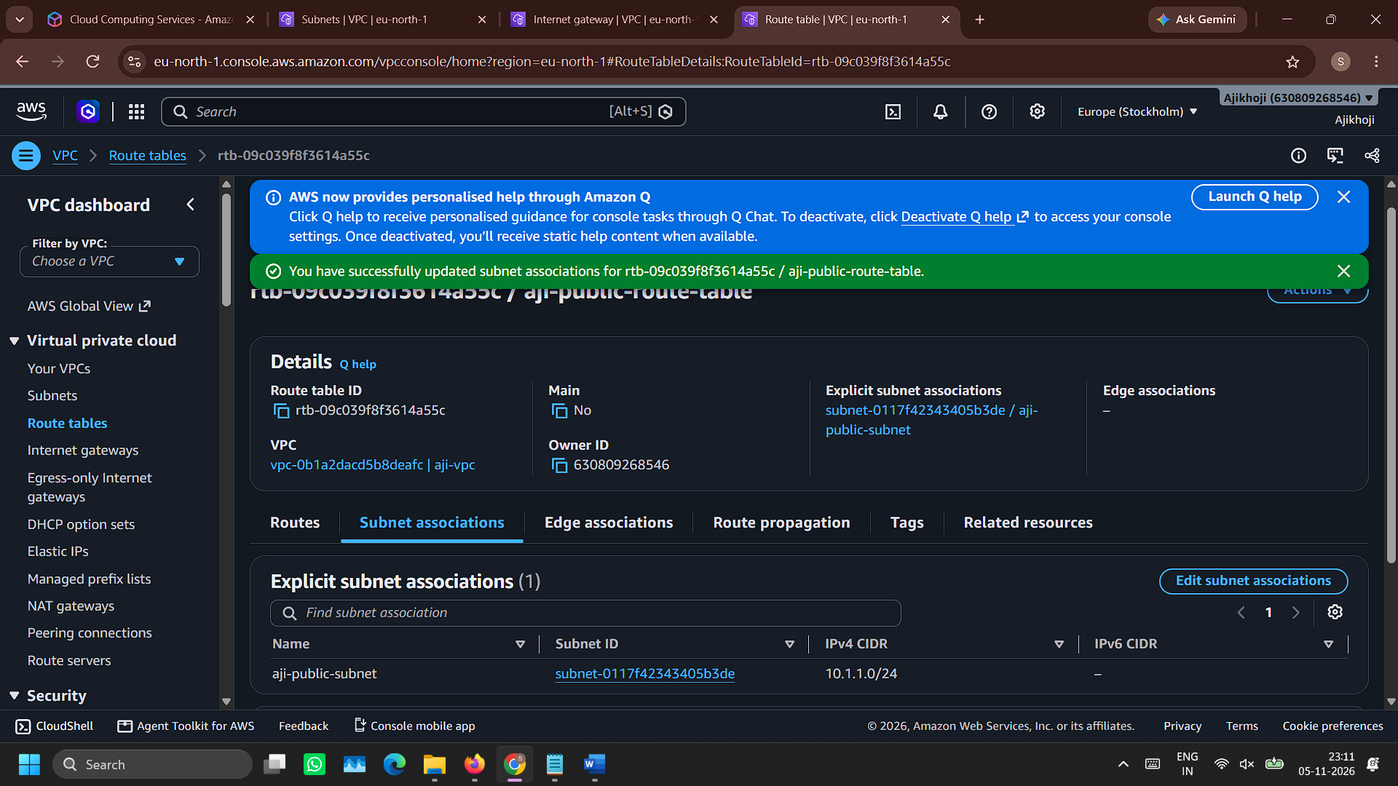

- Allocate new elastic IP Address (which will be later used in NAT)
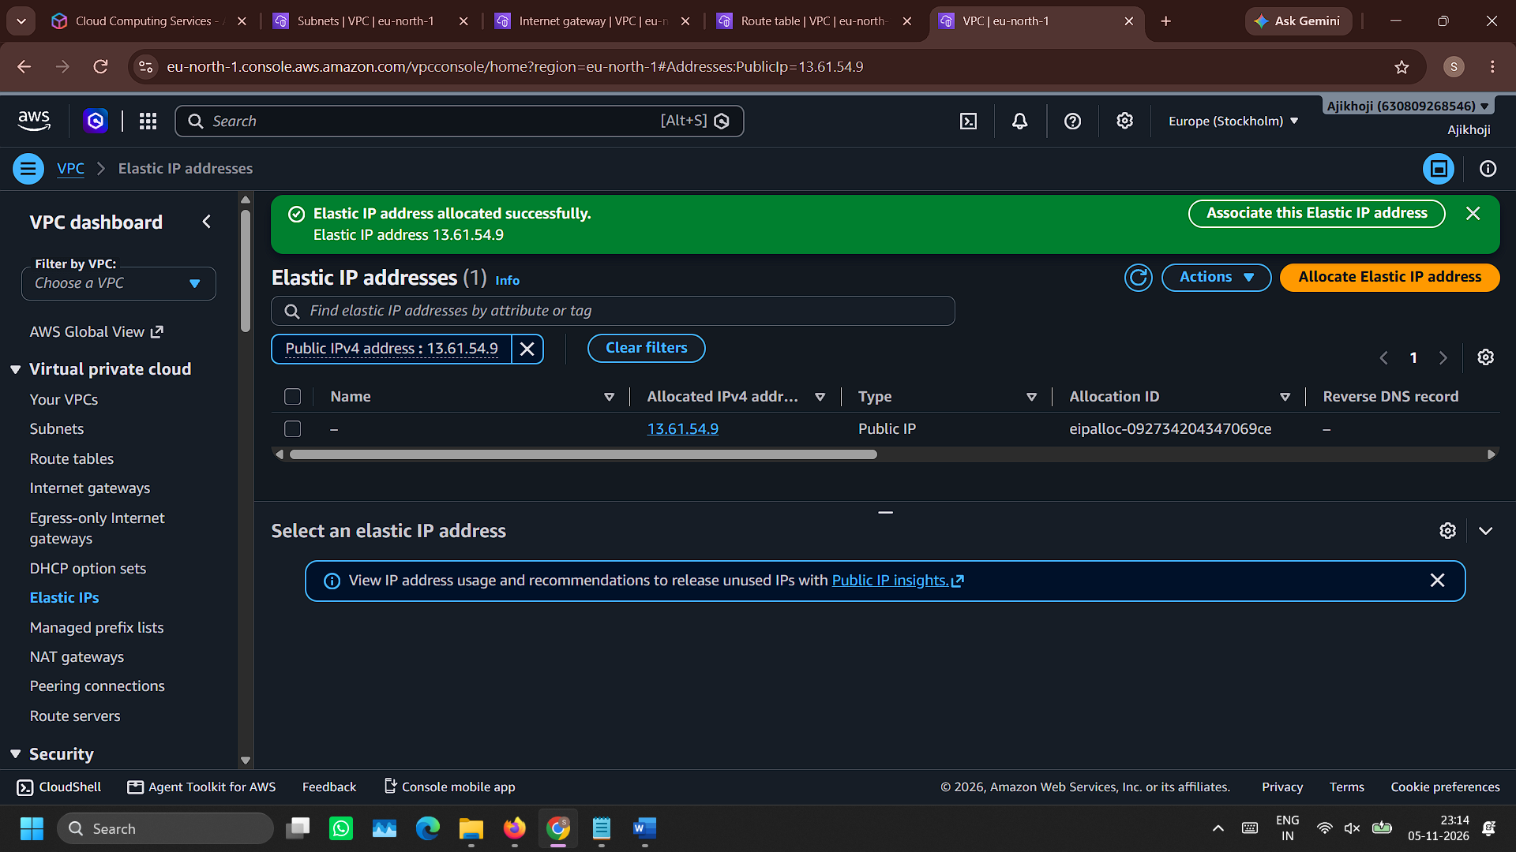

- Create NAT gateway with name aji-nat-gateway and choose aji-public-subnet as subnet
Wait for the state to become ‘Available’
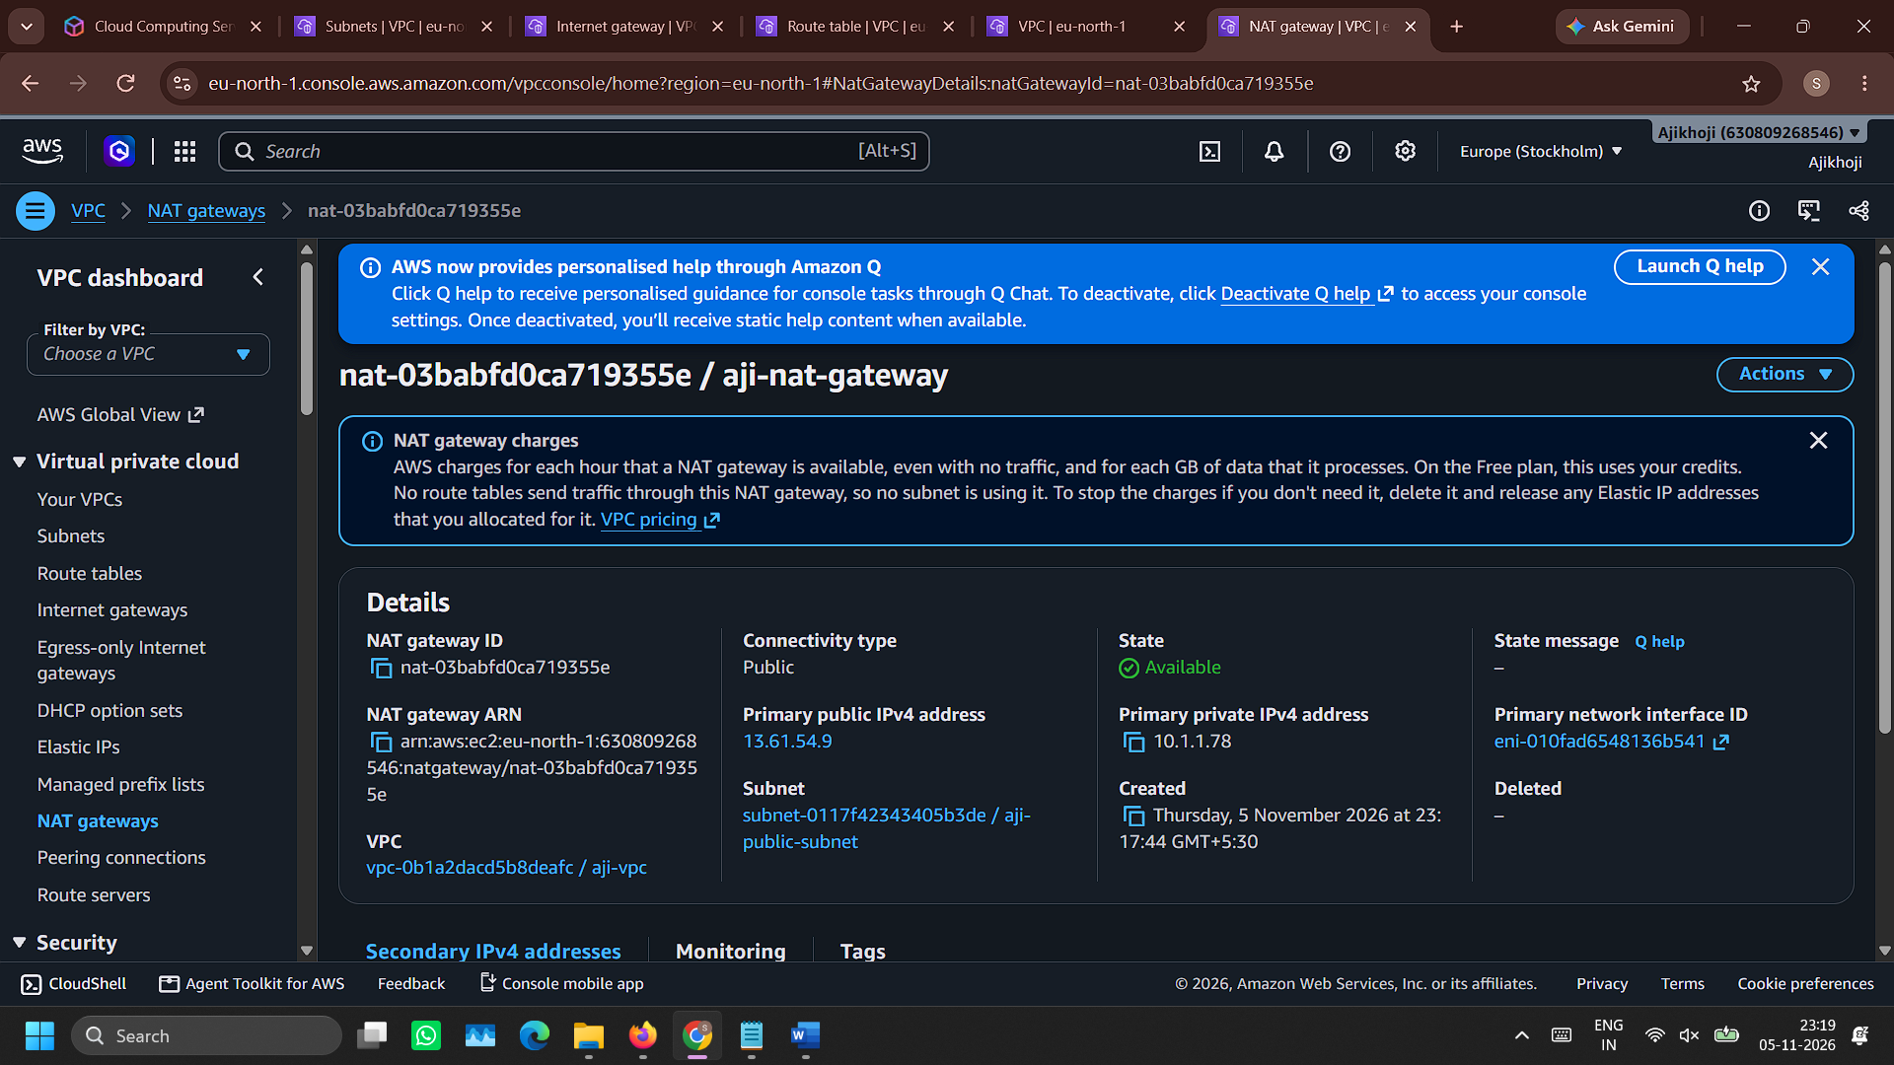

- Create a route table for private subnet with name aji-private-route-table
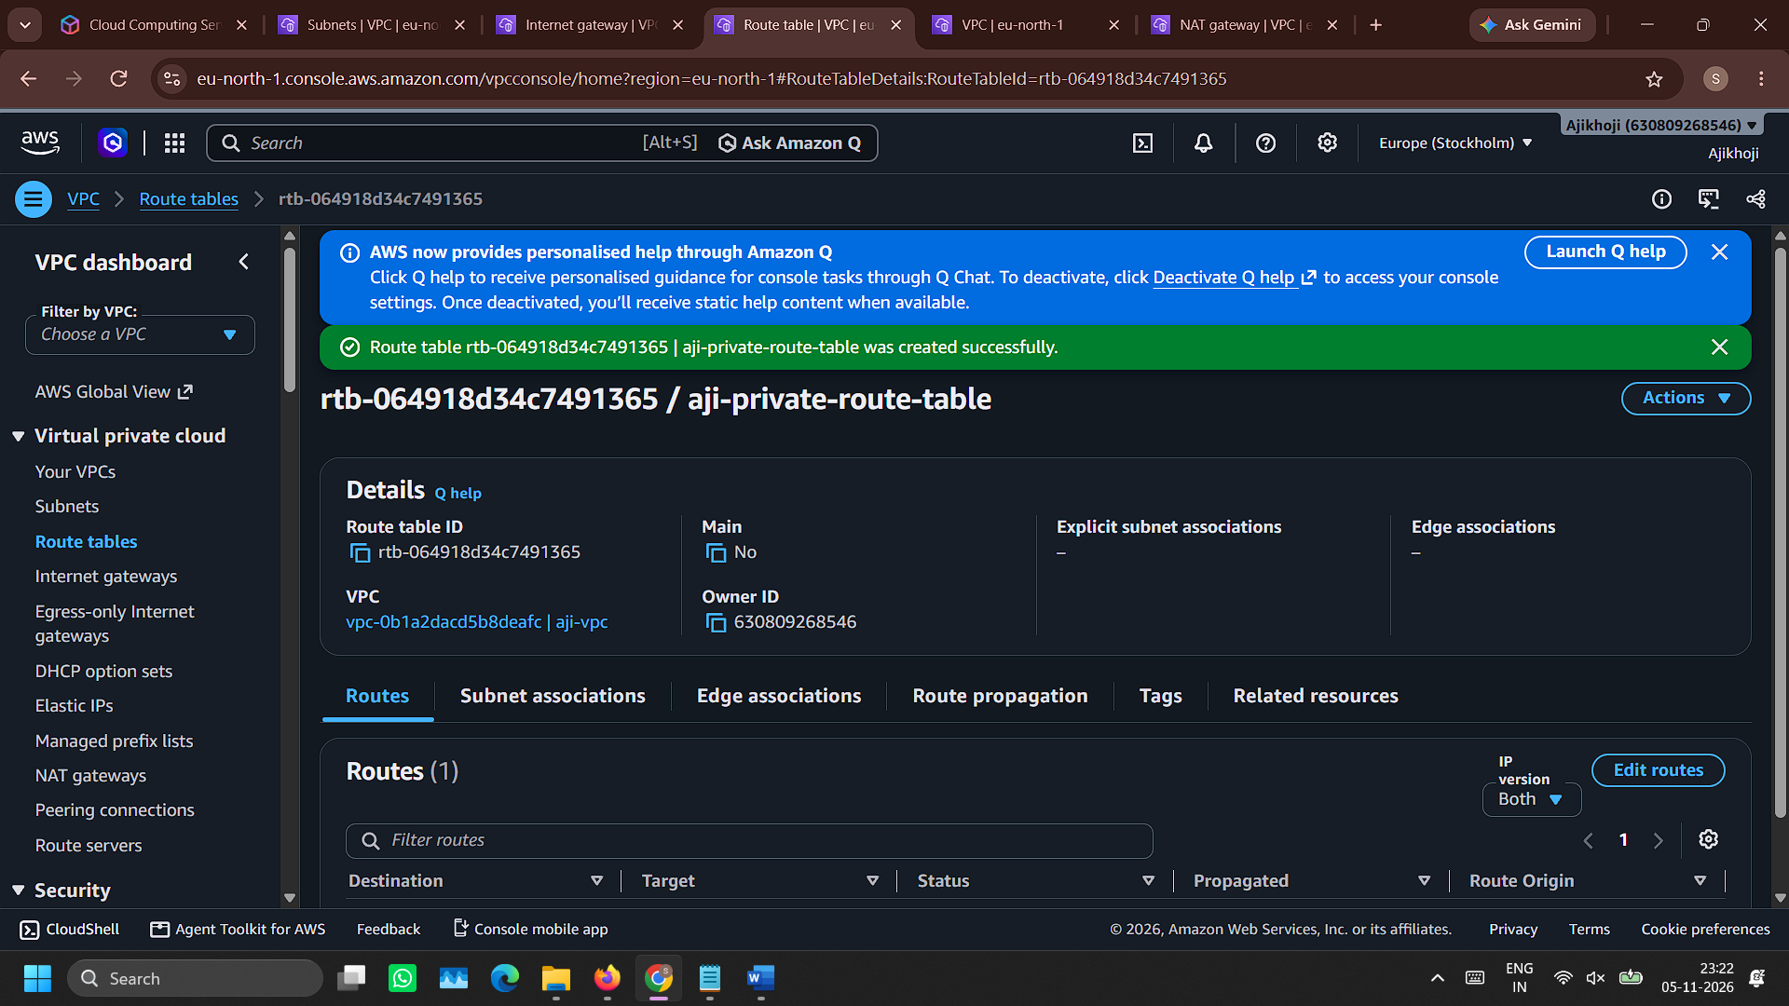

- Configure aji-private-route-table routes to allow NAT gateway aji-nat-gateway
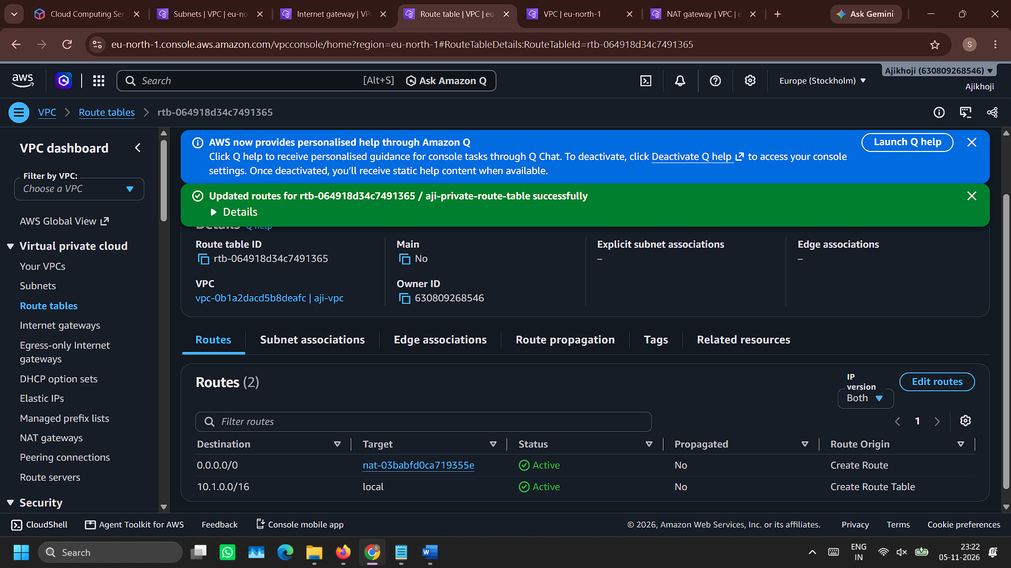

- Associate route table aji-private-route-table with subnet aji-private-subnet
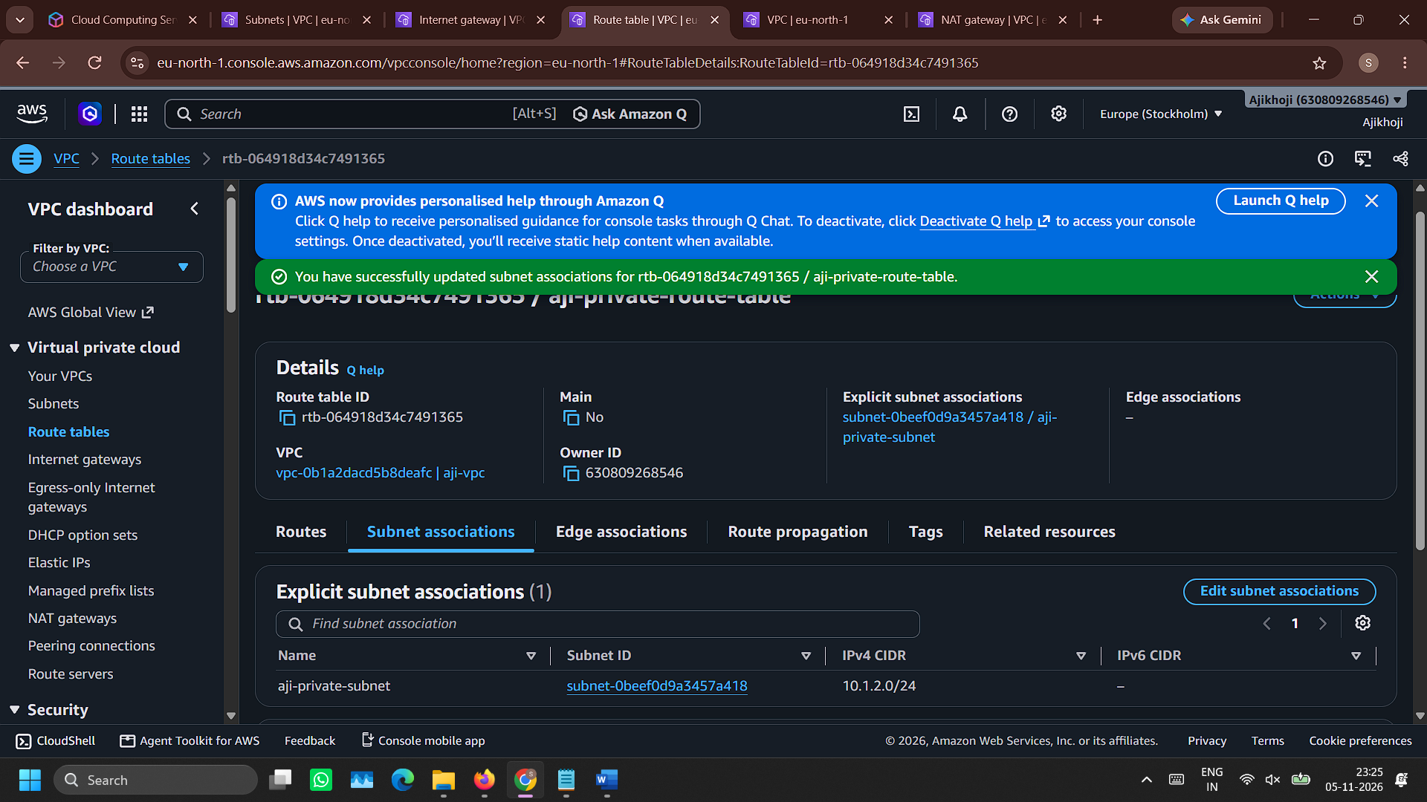

- Create security group aji-public-security-group with SSH (My-IP), HTTP (Anywhere IPv4) and HTTPS (Anywhere IPv4) configuration in inbound rule
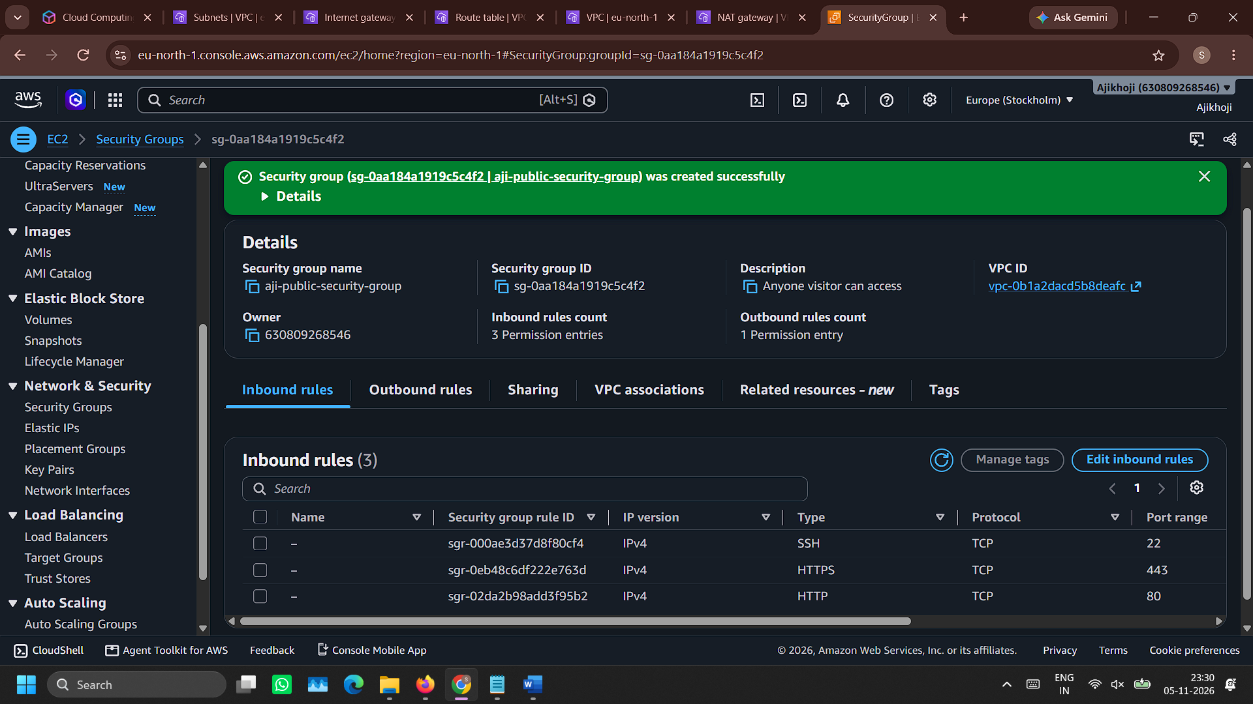

- Create security group aji-private-security-group with SSH, HTTP and HTTPS (all with aji-public-security-group as source) configuration in inbound rule
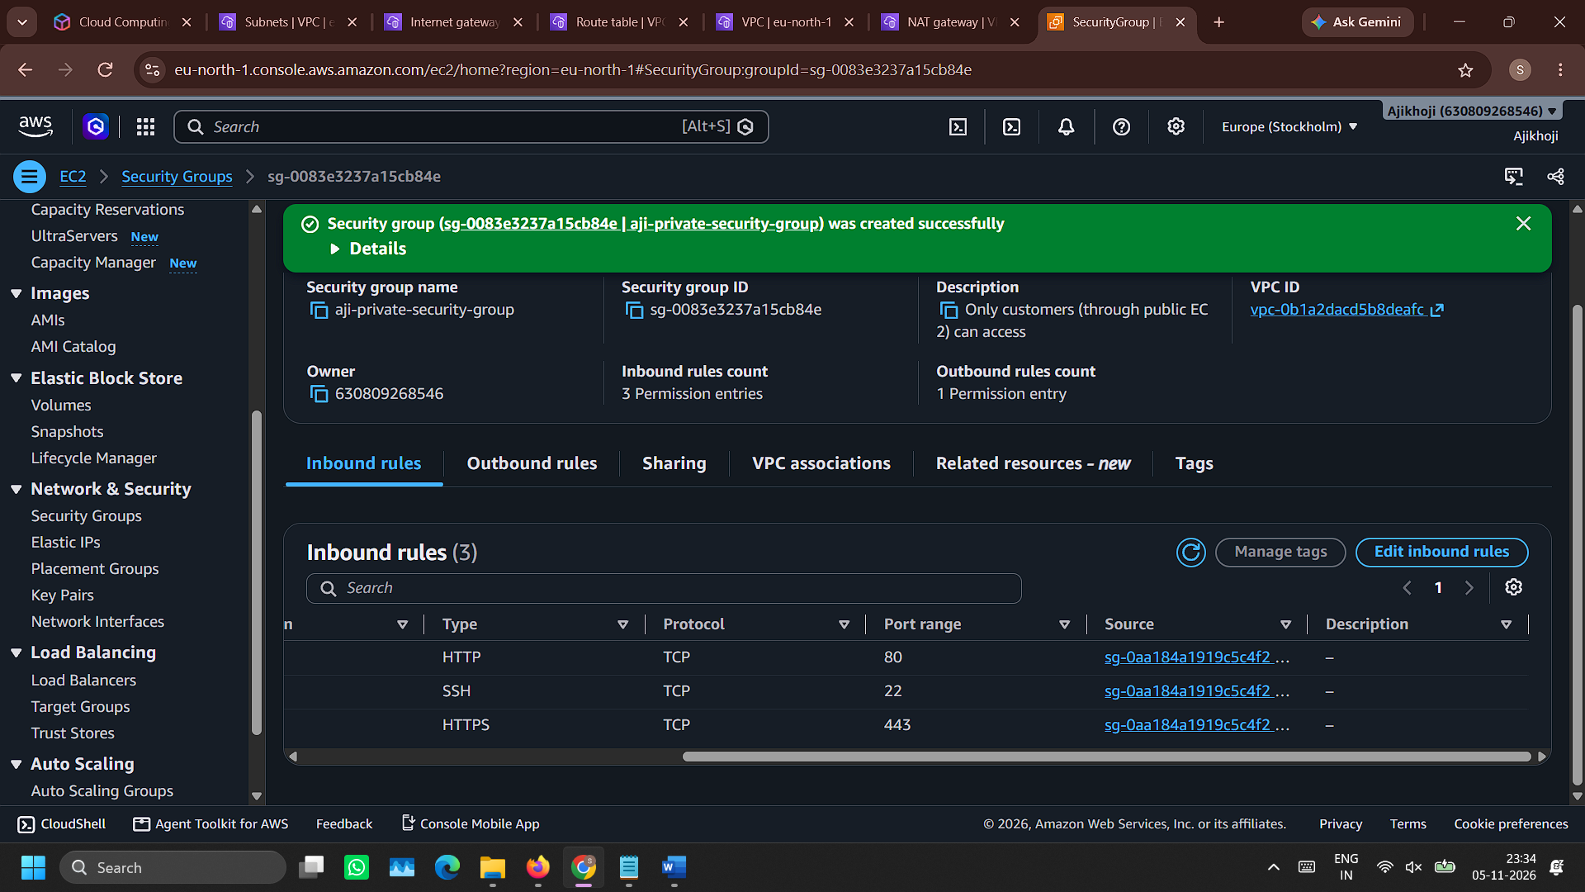

- Create an EC2 named aji-public-server and host publicly accessible home page.
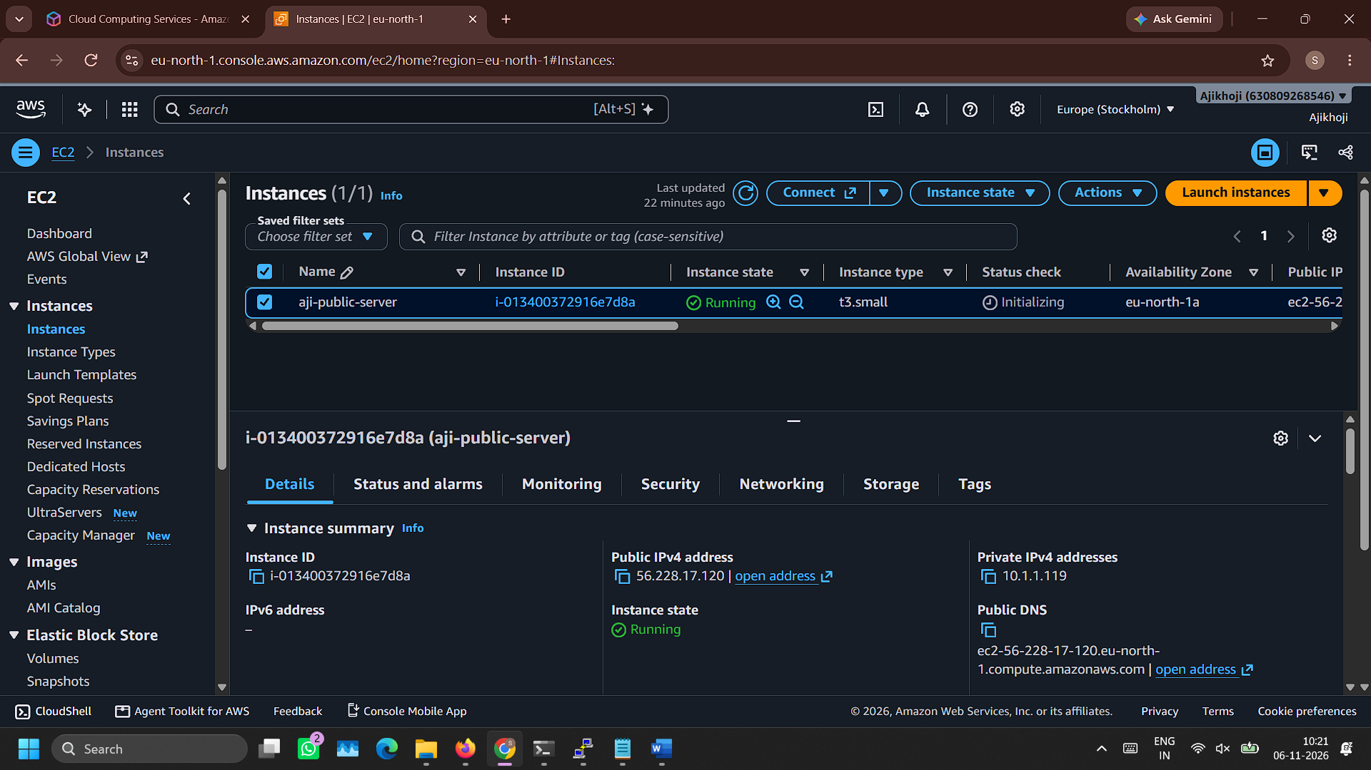

- Home page hosted in public EC2
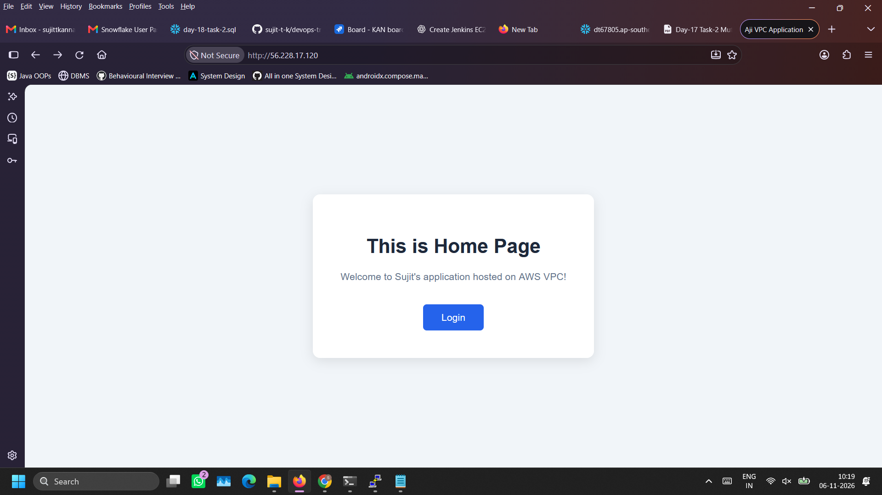

- Create an EC2 named aji-private-server to host login page.
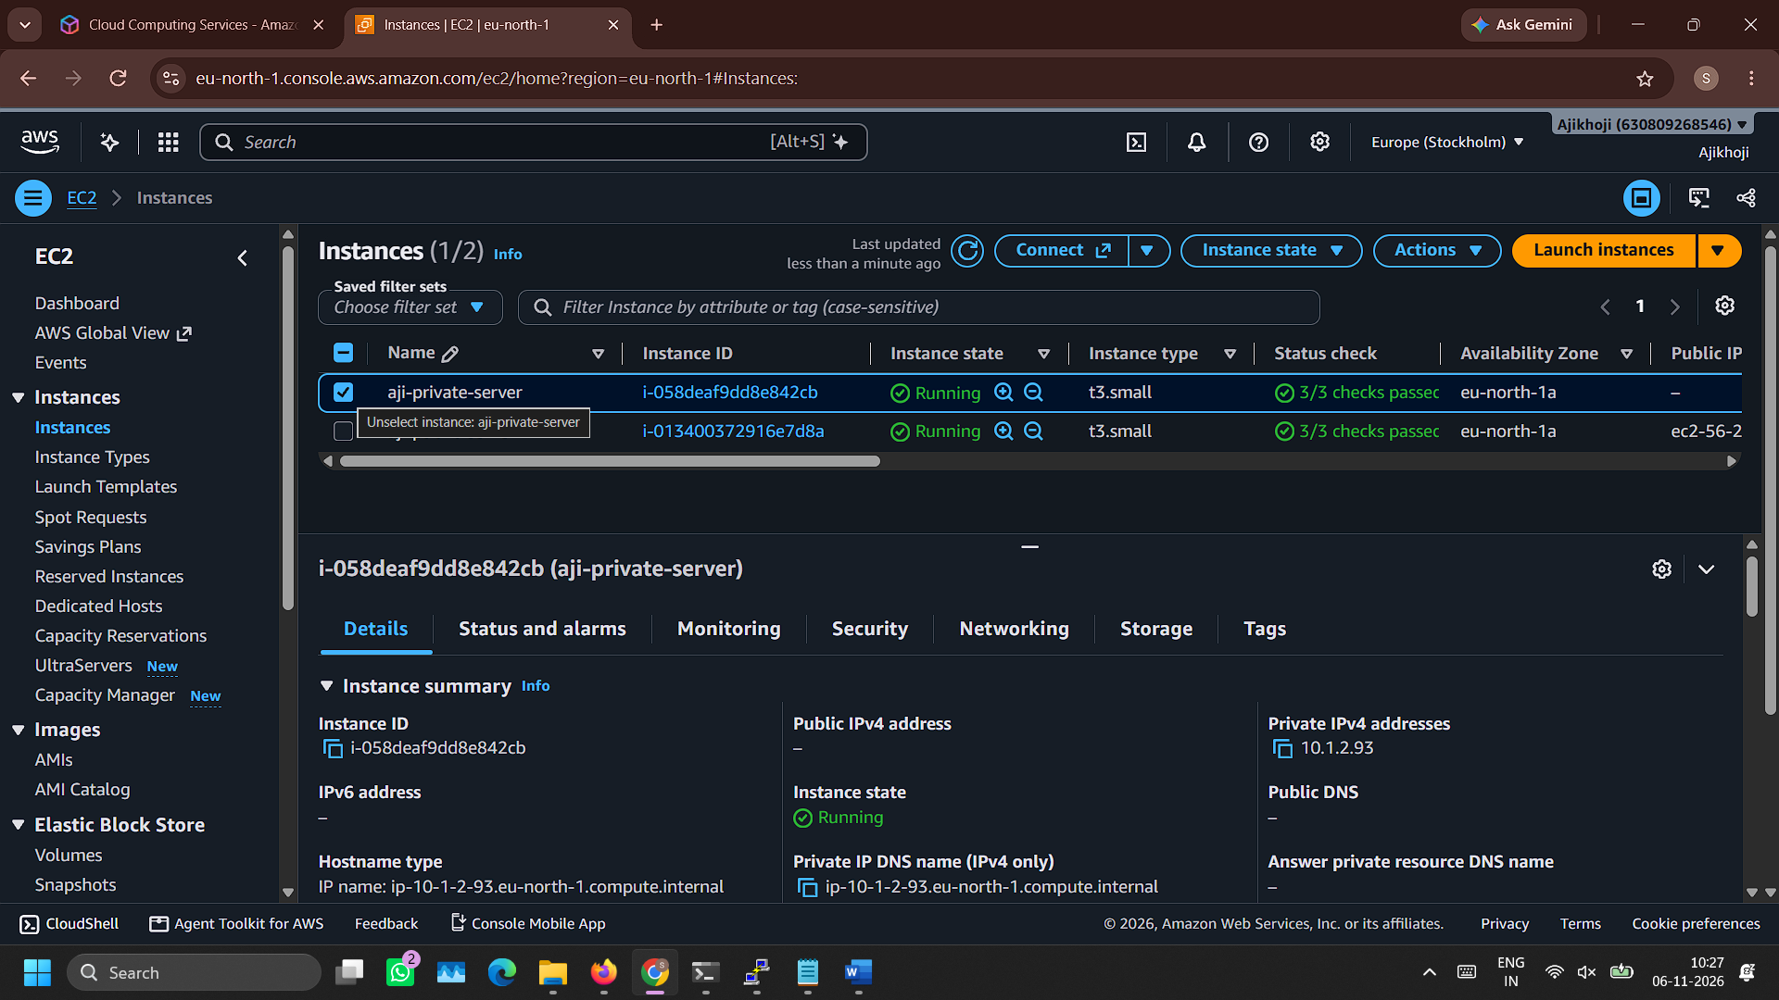
Note that there wouldn’t be any public IPv4 address as it shouldn’t be accessed publicly. It can be accessed only through public EC2 instance.

- Access private server’s SSH from public server’s SSH:
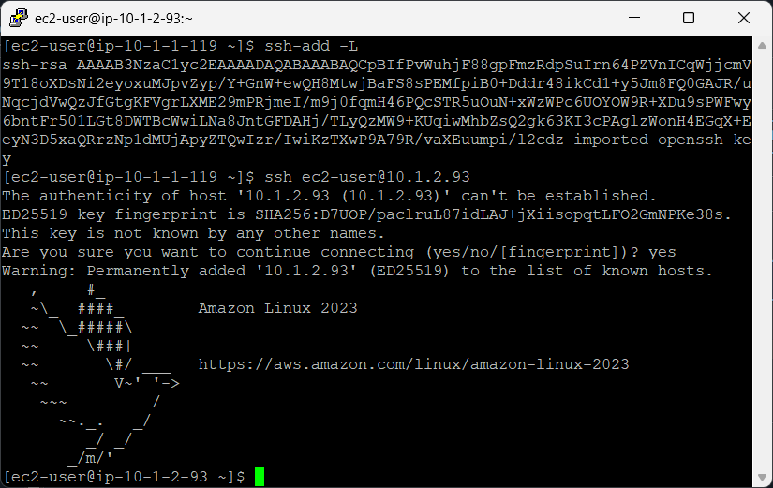

- Install nginx and setup Login page into private server and configure reverse proxy from public server
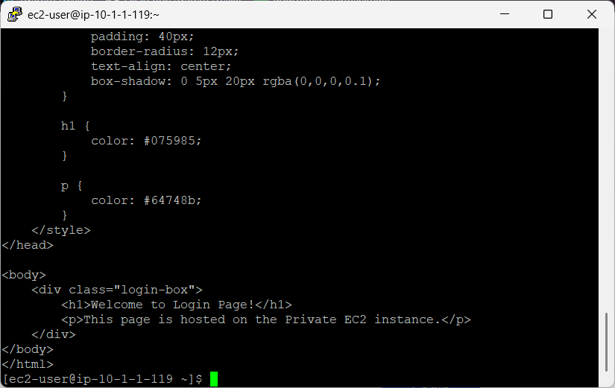
- Click on ‘Login button’ of home page which redirects to Login page.
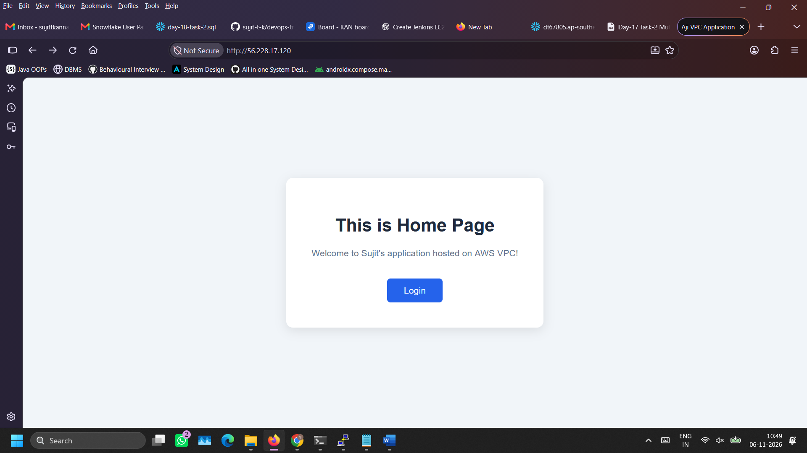
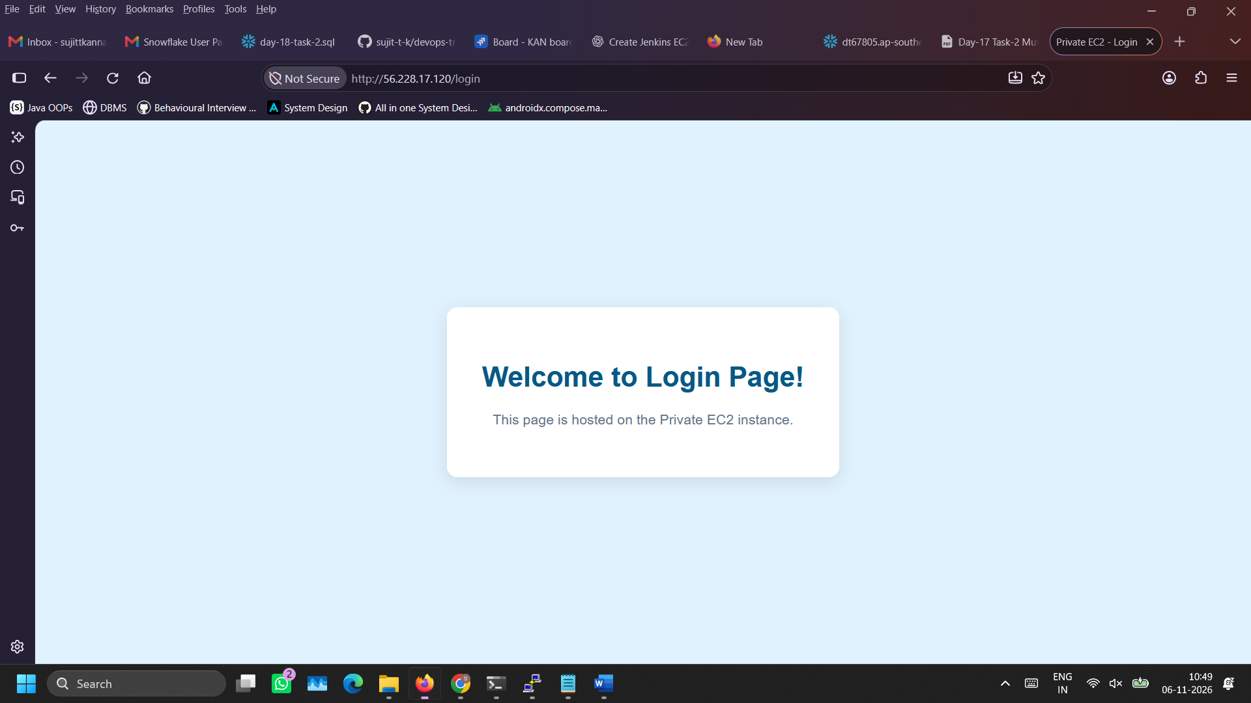

- Deletion of resources:
Terminate EC2 instances
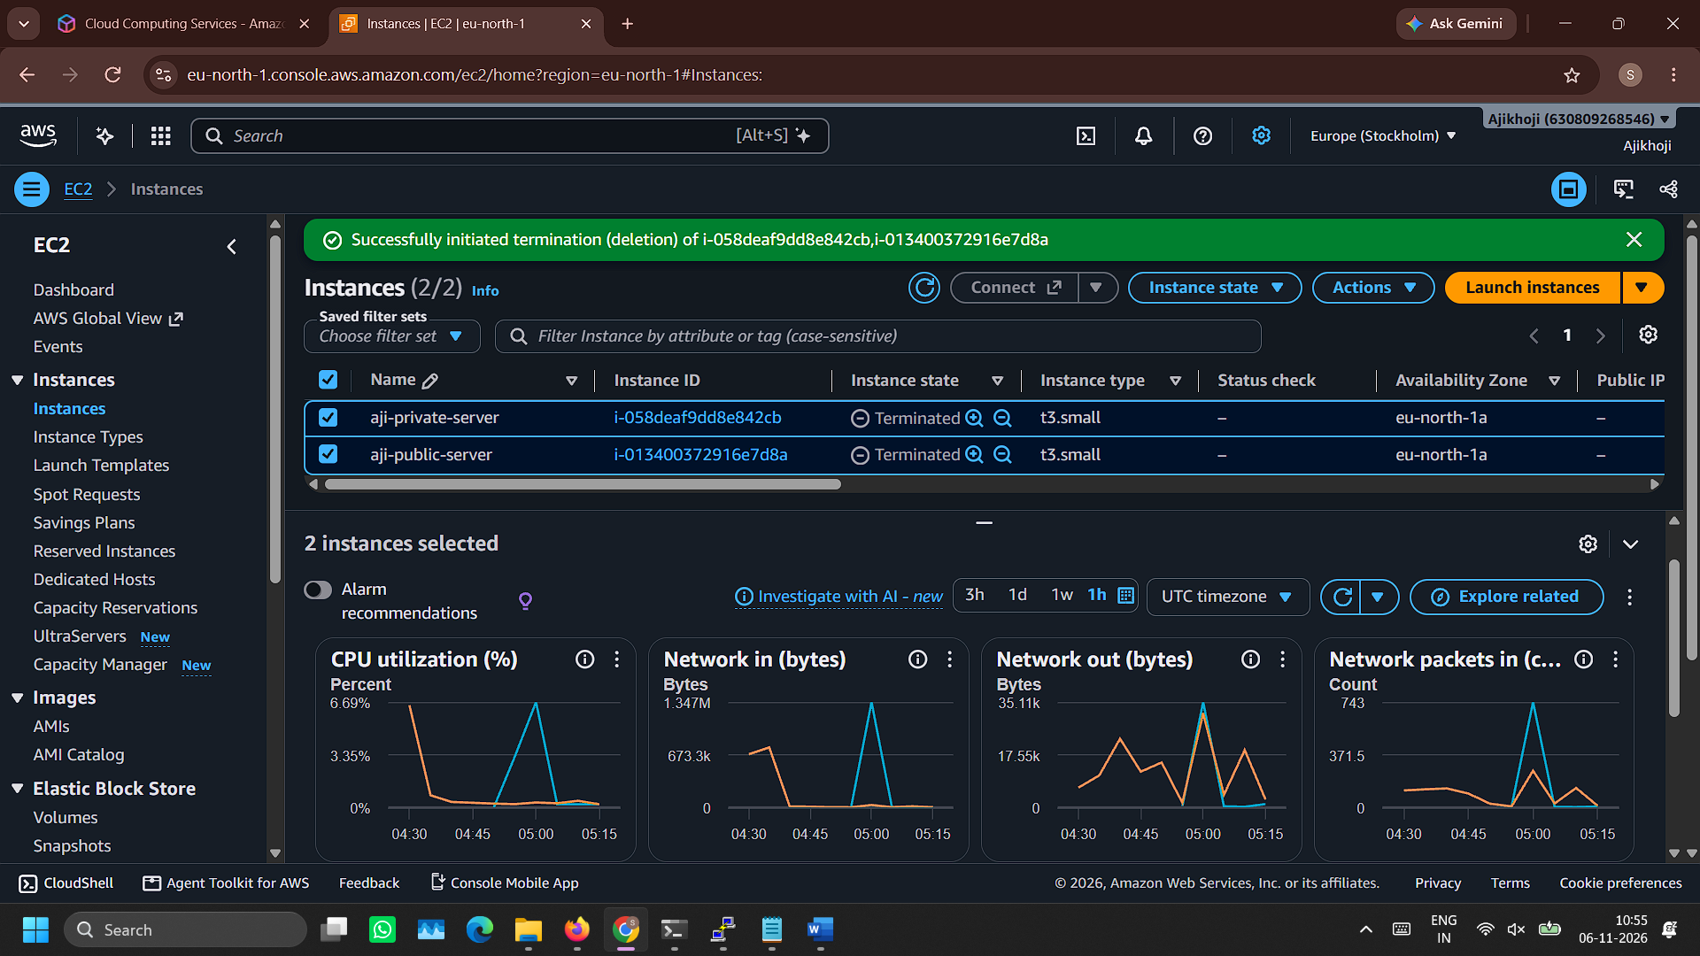

Delete NAT Gateway
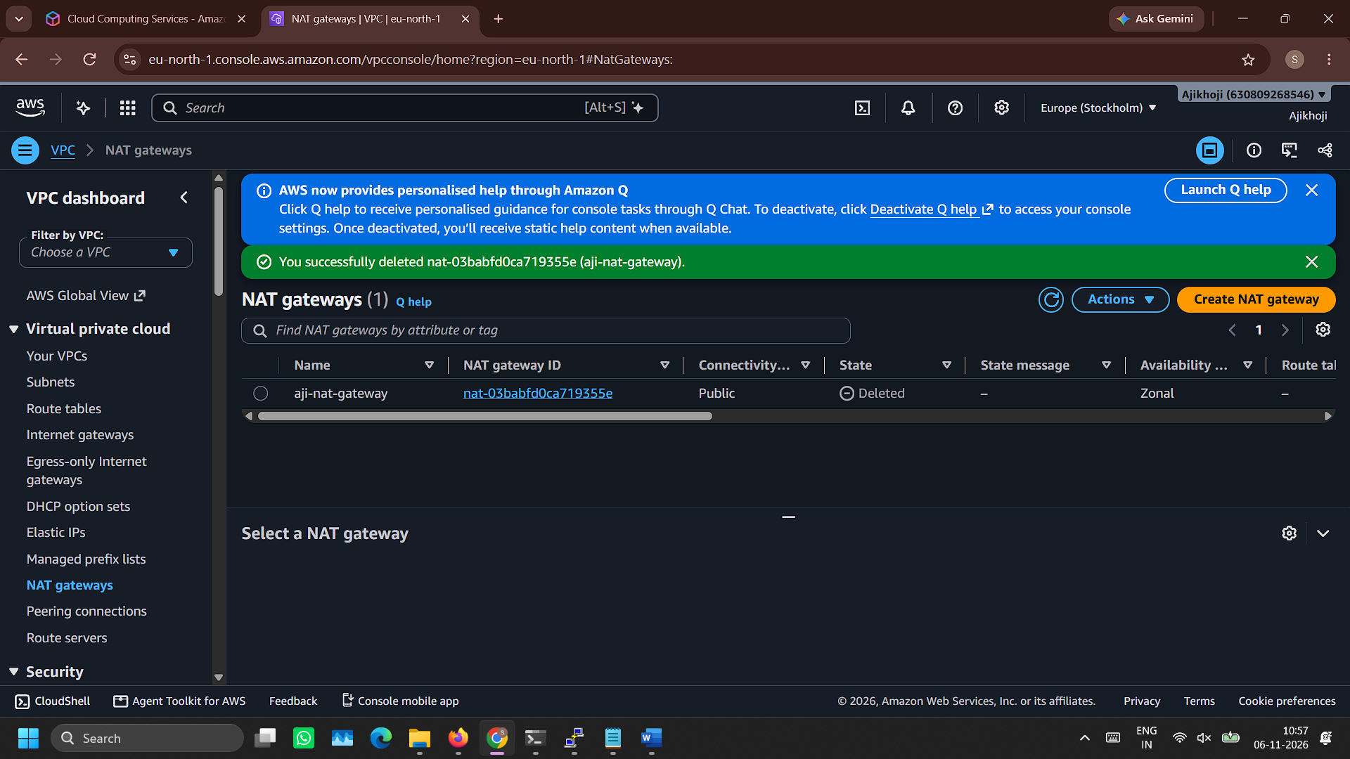

Release Elastic IP address
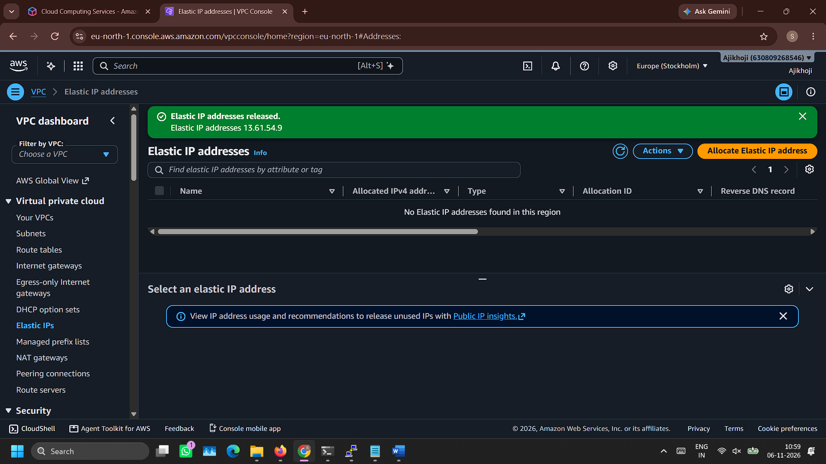

Delete Internet Gateway
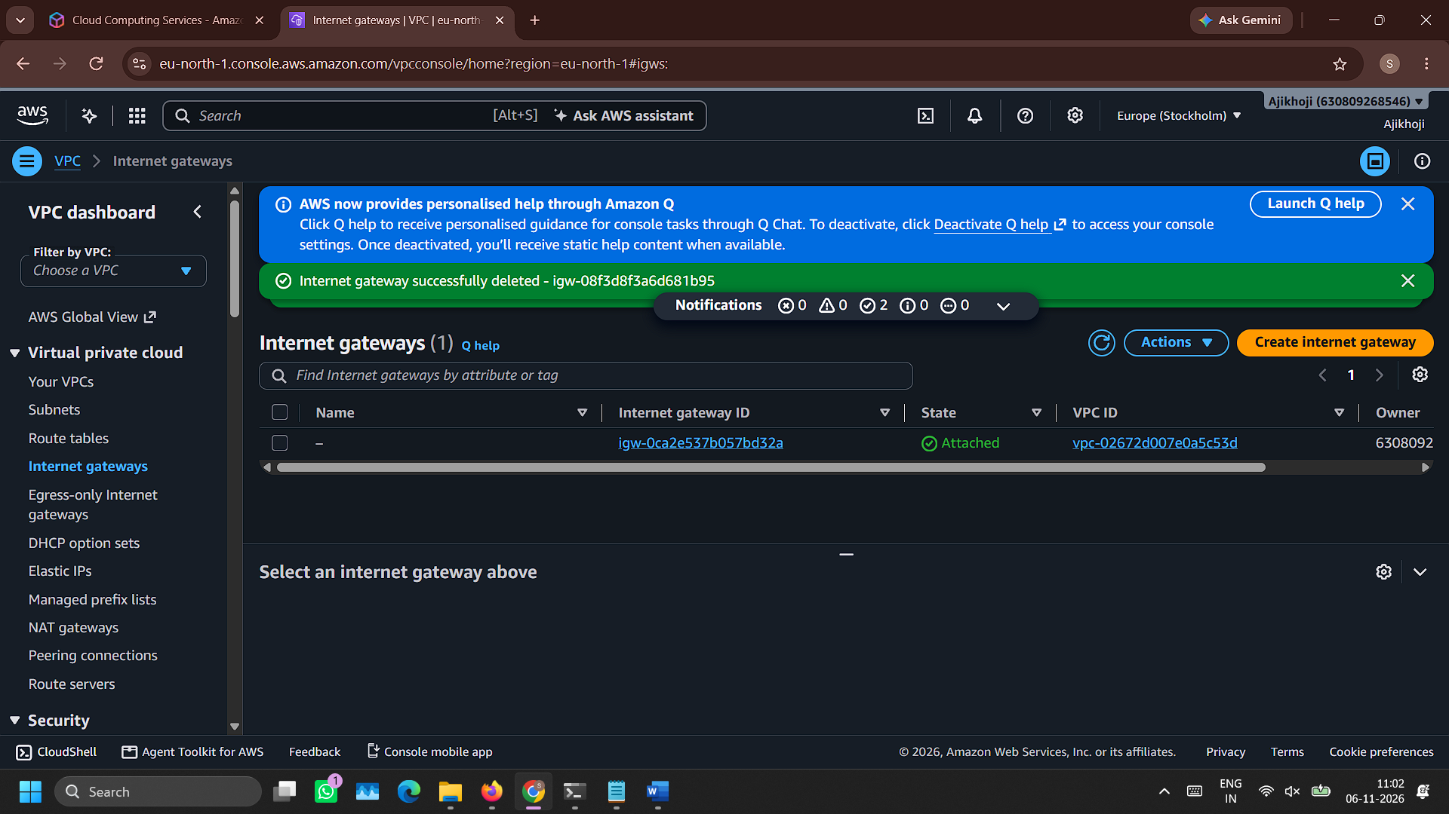

Delete security groups
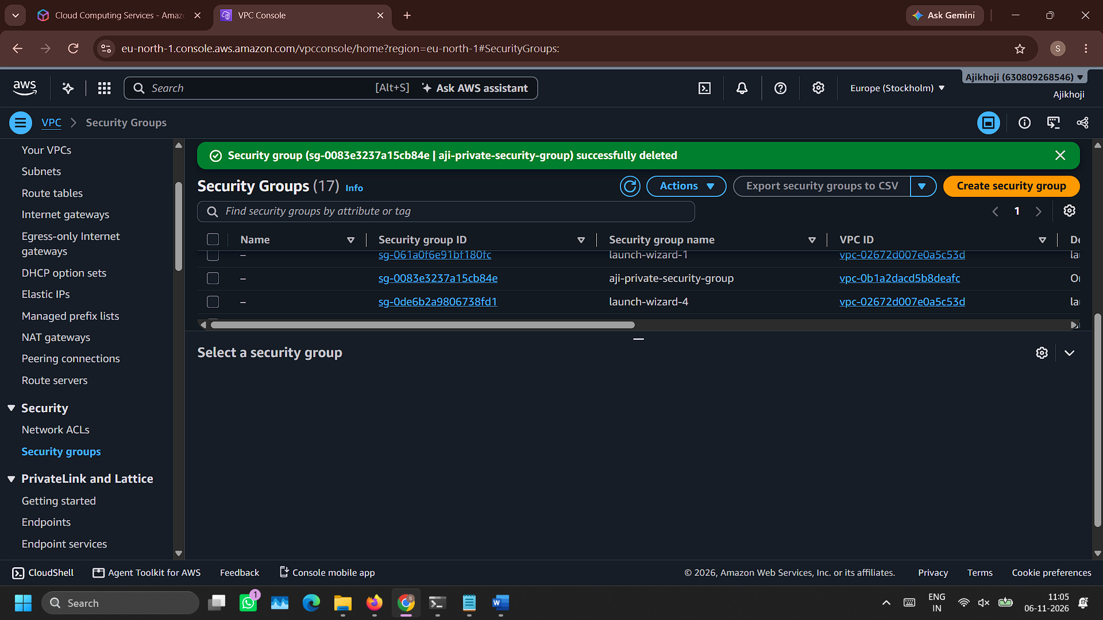

Delete route tables
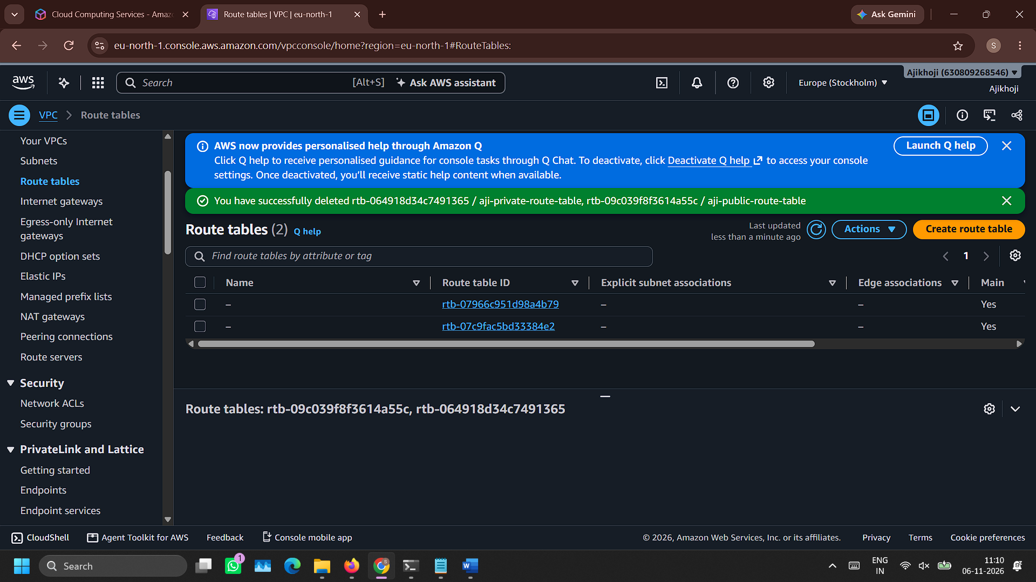

Delete subnets
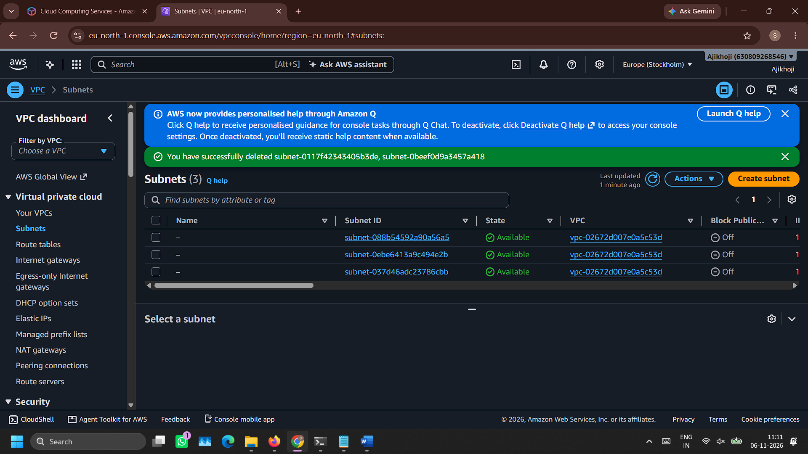

Delete VPC


